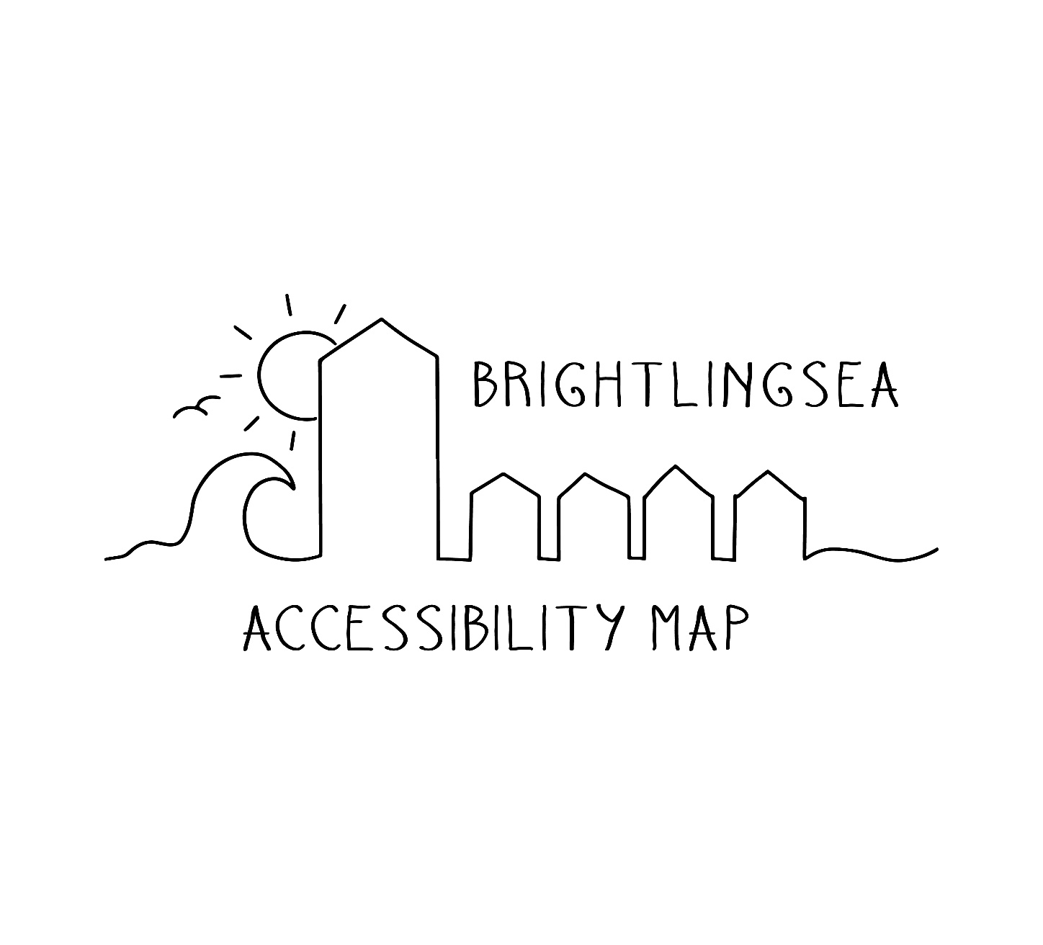
Brightlingsea Carnival
The event takes place this year on Saturday 20th June on Bayard Recreational Ground. There will be a procession around the town and then activities on the rec’. For more details please see https://www.facebook.com/groups/185667951525098

 | Level access to the rec’. Grass surface in the main, suitable for mobility scooters.
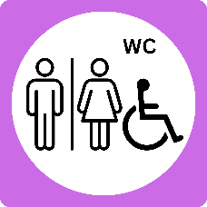 | Toilets onsite by the cricket club. Disabled porta-toilet will be onsite at the rec’ for the event.
 | Procession around town will have live music, performers and crowds. Quieter areas to watch are nearer the beginning of the route.
 | Bring a chair to sit on if you need to sit.
 | Live music and displays during the event.
 | Limited on street parking. Short walk uphill from the town to the rec’.

For more information
scan the QR code
